DEPARTMENT OF CHEMISTRY
K SANTOSHI LEC IN CHEMISTRY

F AF o


Inorganic Chemistry Communications 178 (2025) 114646
Contents lists available at ScienceDirect

Inorganic Chemistry Communications

journal homepage: www.elsevier.com/locate/inoche

Research Article
Enhanced photoluminescence and photocatalytic activity of Eu-Substituted YbFeO₃ nanoparticles synthesized via the Sol-Gel method
Kottana Santhosi , Niranjan Patra *

Department of Chemistry, Koneru Lakshmaiah Education Foundation, Greenfield, Vaddeswaram, Andhra Pradesh 522502, India

A R T I C L E I N F O

Keywords:
Sol-gel
X-ray diffraction Band gap Photoluminescence
Photocatalytic activity
A B S T R A C T

The Yb_{1—x}Eu_{x}FeO₃(x = 0.1 — 0.4) nanoparticles (NPs) were successfully synthesized using a sol–gel method. X- ray diffraction analysis revealed an average crystallite size of approximately 102 nm with a strain of 0.273 for the optimised specimen (x = 0.3) sample. Raman spectroscopy further elucidated internal structural distortions arising from fluctuations in bond distances and bond angles. Reflectance differential spectroscopy was employed to determine band gap energies (E_{g}) for Yb_{1—x}Eu_{x}FeO₃(x = 0.1 — 0.4) are varied in between 2.01 eV to 2.30 eV.

In addition to structural analysis using UV–visible absorption and photoluminescence, the ligand-to-metal charge transfer from the tartrate ligand to the lowest unoccupied energy levels of Eu³⁺ metal ions in the nanoparticles (NPs), along with the f-f transitions of Eu³⁺, are crucial for the emergence of photoluminescence in the ligand- functionalized Yb_{1—x}Eu_{x}FeO₃(x = 0.1 — 0.4) NPs. The photocatalytic activity of these materials was assessed, and among them the sample x = 0.3 demonstrating the most effective performance in photocatalytic applications.

1. Introduction

The multifunctional properties of rare earth orthoferrites (RFeO₃, where R represents a rare earth element) have attain significant atten- tion for a variety of applications, including gas sensors, membranes, active catalysts oxidation [1–4]. The electrical and optical characteris- tics of multiferroic nanocrystals, especially RFeO₃ nanoparticles, are distinctive and remain separate throughout exchange processes [5,6]. RFeO₃ nanoparticles typically adopt a distorted orthorhombic structure with the Pnma/Pbnm space group, falling within the perovskite family [7]. The material properties of Fe-O-Fe bonds are influenced by struc- tural distortions, which can be quantified by the angles of these bonds. In these compounds, each rare earth ion (R³⁺) is surrounded by 12 ox- ygen ions (O^{2—}) with 8 of these being the nearest neighbours and 4 being the second closest. To enhance the magnetic and transport properties of RFeO₃ perovskites, numerous studies have explored methods such as site substitution of by either R or Fe. Additionally, significant research has been conducted on the impact of various alkaline metal cations, such as Ca²⁺ and Sr²⁺, on the substitution of rare earth elements (R) in RFeO₃ orthoferrites. It has been demonstrated that specific properties can be controlled and improved by substituting the Eu³⁺ (~0.095 nm) site in YbFeO₃ with the nonmagnetic Yb³⁺ ion (~0.087 nm). Substituting Yb³⁺ ions (ionic radius ~ 0.087 nm) with slightly larger Eu³⁺ ions (ionic
radius ~ 0.095 nm) in the YbFeO₃ lattice can induce structural distor- tions due to the size mismatch. This change in ionic radii is known to affect the crystallographic parameters, potentially leading to modifica- tions in lattice strain, unit cell volume, and crystallite size, which in turn can influence the material’s functional properties [8]. The structural, electrical, and optical properties of RFeO₃ orthoferrites are also influ- enced by modifications to R-site and Fe site, although relatively few studies have explored these effects. Previous research has shown that variations in the cation content of RFeO₃ compounds can significantly impact their distinct characteristics within the perovskite family [9].
The rare-earth multiferroic YbFeO₃ exhibits moderate ferromagne- tism at high temperatures, compared to all orthoferrites. This is attrib- uted to the non-collinear spin arrangement of the iron ions (Fe³⁺). Rare earth ions are rarely found in the spaces between the FeO₆ oxygen octahedra in a disordered paramagnetic state. The orthorhombic struc- ture with space group Pnma (D¹⁶) describes the crystal symmetry of RFeO₃ orthoferrites, which aligns with the magnetic symmetry [10]. The unit cell contains 4-Fe³⁺ and 4-R³⁺ ions. Distortions in the cell arise from the tilting of the FeO₆ octahedra around the orthorhombic axes b and c. The spin-reorientation transfer occurs within the ac plane. These tilts cause the Fe-O-Fe bonds to deviate from their ideal 180◦ alignment. The antiferromagnetic structure and macroscopic magnetism of RFeO₃ orthoferrites have been experimentally validated through the
2h

* Corresponding author at: Department of Chemistry, Koneru Lakshmaiah Education Foundation, Greenfield, Vaddeswaram, Andhra Pradesh, India.
E-mail address: patraji@gmail.com (N. Patra).

https://doi.org/10.1016/j.inoche.2025.114646
Received 20 March 2025; Received in revised form 19 April 2025; Accepted 1 May 2025
Available online 5 May 2025
1387-7003/© 2025 Elsevier B.V. All rights are reserved, including those for text and data mining, AI training, and similar technologies.

Journal of Sol-Gel Science and Technology https://doi.org/10.1007/s10971-025-06926-y


ORIGINAL PAPER
Role of calcination temperature in modulating optical and structural properties of sol–gel synthesized Yb_{0.7}Eu_{0.3}FeO₃ orthoferrites
Kottana Santhosi¹ ● Niranjan Patra¹

Received: 12 June 2025 / Accepted: 27 August 2025
© The Author(s), under exclusive licence to Springer Science+Business Media, LLC, part of Springer Nature 2025

Abstract
In this investigation, the Yb_{0.7}Eu_{0.3}FeO₃ nanoparticles were prepared via the sol-gel method and optimized the calcined temperature (800 °C, 850 °C and 900 °C) to revels the optimized physical performance. X-ray diffraction (XRD) and Rietveld refinement confirmed a single-phase orthorhombic (Pnma) crystal structure with enhanced crystallinity at higher temperatures. An increase of calcination temperatures increases the crystallite size while inducing octahedral tilting and strain. The average particle size for Yb_{0.7}Eu_{0.3}FeO₃ calcined at 800, 850 and 900 °C was 152, 161 and 168 nm, respectively was observed through scanning electron microscopy (SEM). The magnetization value increased from 2.721 emu/g to 3.789 emu/g with an increase of calcination temperature from 800 °C to 900 °C for Yb_{0.7}Eu_{0.3}FeO₃ sample. Magnetic measurements indicated improved Fe³⁺–Fe³⁺superexchange interactions, with the 900 °C sample exhibiting superior magnetization. A strong red photoluminescence was observed under 532 nm excitation, dominated by the ⁵D₀ → ⁷F₂ transition of Eu³⁺, with intensity increasing alongside temperature due to improved local symmetry. X-ray photoelectron spectroscopy (XPS) confirmed the oxidation states of each ion along with ~20.12% oxygen vacancies, contributing to the observed functional behavior. The findings underscore the critical role of calcination in tuning multifunctional properties, highlighting Yb_{0.7}Eu_{0.3}FeO₃ as a promising candidate for optoelectronic and magneto-optic applications.

Graphical Abstract
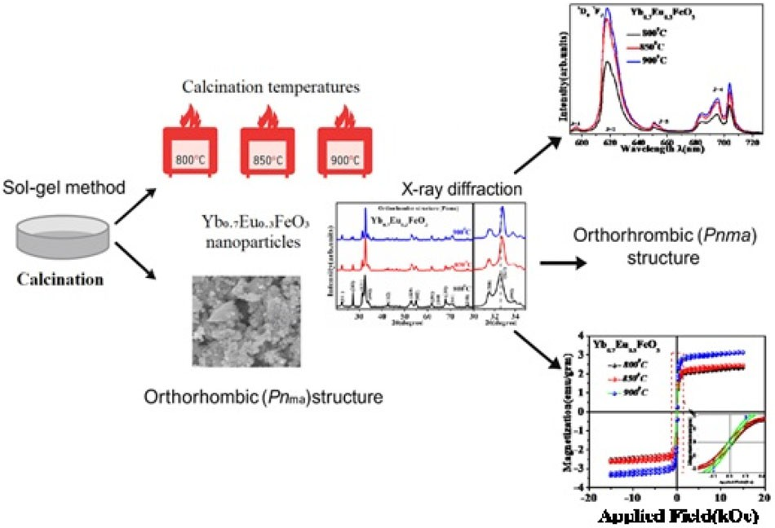

Keywords Sol–gel synthesis ● Nanoparticles ● Photoluminescence ● Magnetic properties ● Super-exchange

Niranjan Patra patraji@gmail.com

¹ Department of Chemistry, Koneru Lakshmaiah Education Foundation, Greenfield, Vaddeswaram 522502 Andhra Pradesh, India

(12) PATENT APPLICATION PUBLICATION (21) Application No.202541020395 A
(19) INDIA
(22) Date of filing of Application :06/03/2025 (43) Publication Date : 21/03/2025

(54) Title of the invention : Europium-Substituted Ytterbium Orthoferrite Nanoparticles with Enhanced Photocatalytic and Photoluminescent Properties and a Method for Their Synthesis

(51) International classification
(86) International Application No
Filing Date
(87) International Publication No
(61) Patent of Addition to Application Number
Filing Date
(62) Divisional to Application Number
Filing Date

(57) Abstract :

:B01J0035390000, C02F0001300000, C02F0101300000, B82Y0040000000, B01J0037030000
:NA
:NA
: NA

:NA
:NA

:NA
:NA
- Name of Applicant :

KOTTANA SANTHOSI
Address of Applicant :Department of Chemistry, KLEF (Deemed To Be University), Koneru Lakshmaiah Education, Foundation, Green Fields, Vaddeswaram, Guntur, Andhra Pradesh 522302 Guntur ----------- -----------

DR. NIRANJAN PATRA
  - KONERU LAKSHMAIAH EDUCATION FOUNDATION
Name of Applicant : NA Address of Applicant : NA
- Name of Inventor :

KOTTANA SANTHOSI
Address of Applicant :Department of Chemistry, KLEF (Deemed To Be University), Koneru Lakshmaiah Education, Foundation, Green Fields, Vaddeswaram, Guntur, Andhra Pradesh 522302 Guntur ----------- -----------

DR. NIRANJAN PATRA
Address of Applicant :Associate Professor, Department of Chemistry, KLEF (Deemed To Be University), Koneru Lakshmaiah Education, Foundation, Green Fields, Vaddeswaram, Guntur, Andhra Pradesh 522302 Guntur ----------- -----------

ABSTRACT “Europium-Substituted Ytterbium Orthoferrite Nanoparticles with Enhanced Photocatalytic and Photoluminescent Properties and a Method for Their Synthesis” The present invention relates to europium-substituted ytterbium orthoferrite (Yb₁₋ₓEuₓFeO₃) nanoparticles with enhanced photocatalytic and photoluminescent properties, as well as a novel sol-gel synthesis method for their preparation. The invention provides a controlled substitution of Eu³⁺ into the YbFeO₃ lattice, resulting in structural distortions that improve charge carrier separation, visible-light absorption, and fluorescence emission. The nanoparticles exhibit a bandgap ranging from 2.01 eV to 2.30 eV, making them highly effective for visible-light-driven photocatalysis. Surface functionalization with disodium tartrate enhances aqueous dispersibility and stability, expanding their practical applications in wastewater treatment, optoelectronics, and bioimaging. The optimized composition (x = 0.3) demonstrates a 90% degradation efficiency of methylene orange dye within 45 minutes under visible light, with a pseudo-first-order kinetic rate constant of 0.0607 min⁻¹. The invention further describes a scalable and cost-effective sol-gel method involving precursor dissolution, chelation, gel formation, controlled thermal annealing, and surface modification. These nanoparticles offer superior photocatalytic performance, strong red fluorescence emission at 615 nm, and long-term stability, making them ideal for environmental remediation, biomedical diagnostics, and luminescent sensing applications.
No. of Pages : 26 No. of Claims : 7

The Patent Office Journal No. 12/2025 Dated 21/03/2025 28372

